# Part 1

1. 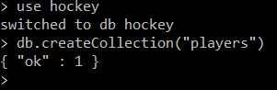
2. 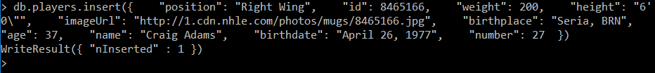
3. MongoDB does not care about duplicates so we have to remove one of those documents ourselves using db.players.remove({„name” : „Craig Adams”}, 1)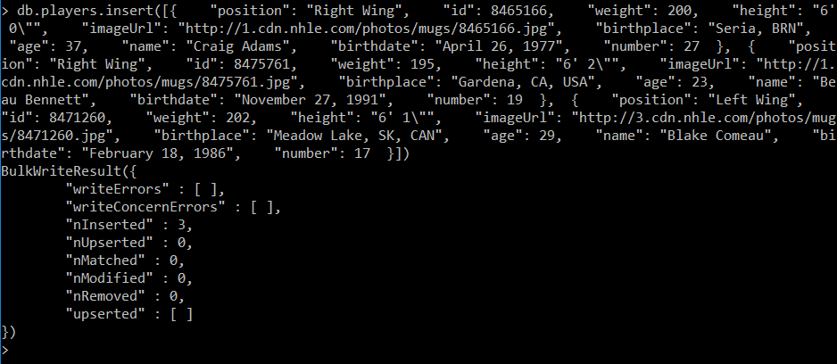
4. 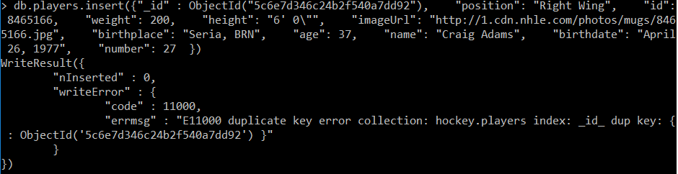
5. 
6. 
7. 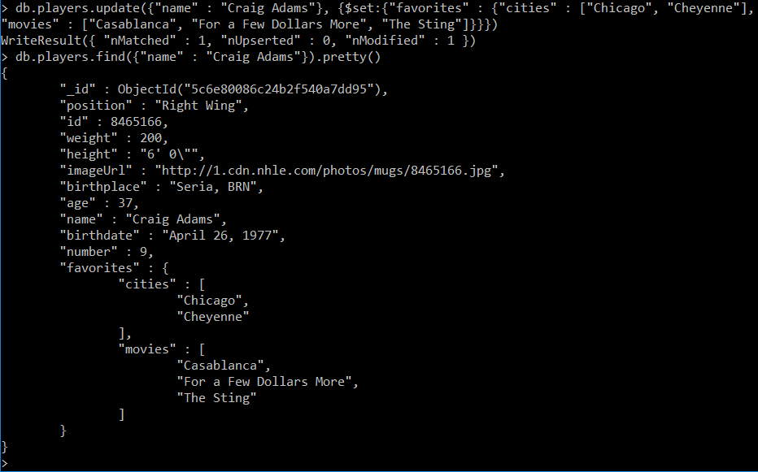
8. 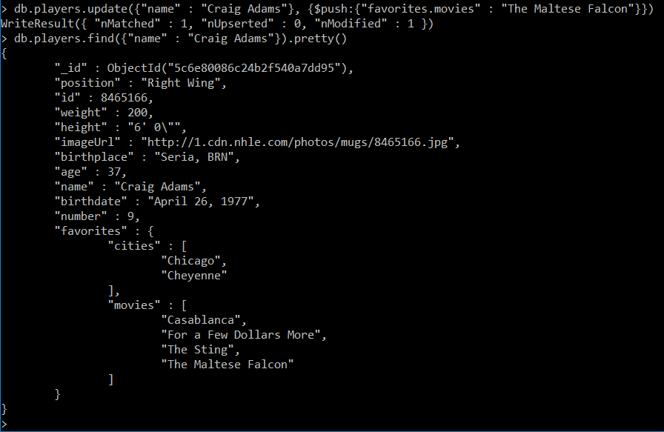
9. 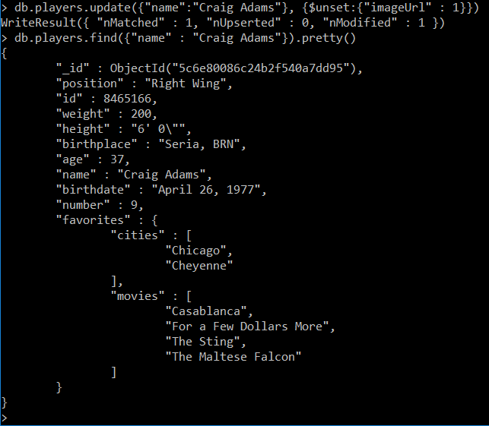
10. 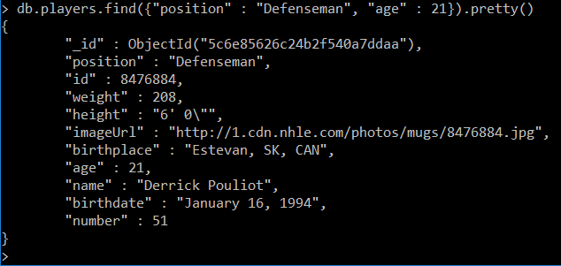

# Part 2

1. 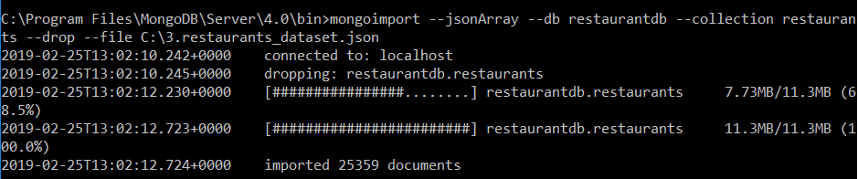
2. 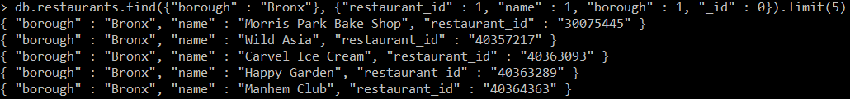
3. 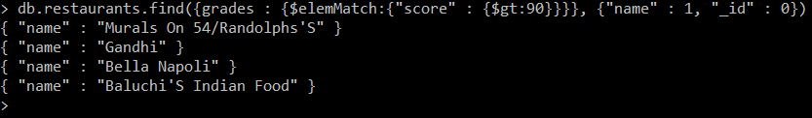
4. 
5. 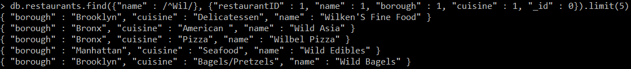
6. 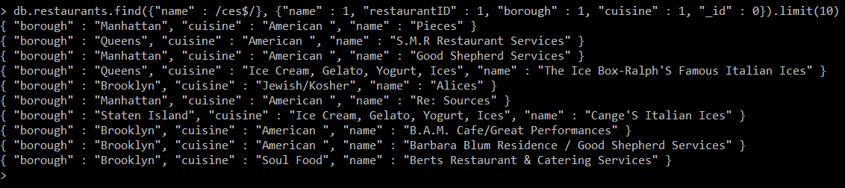
7. 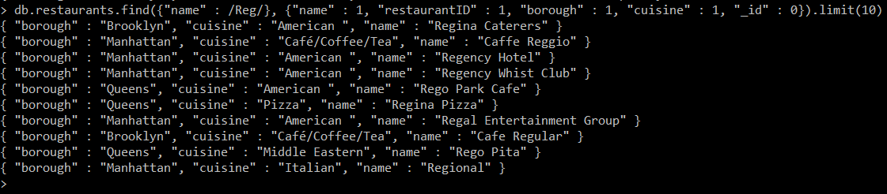
8. 
9. 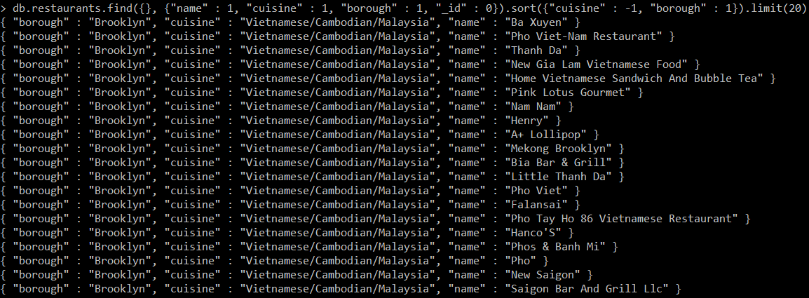
10. 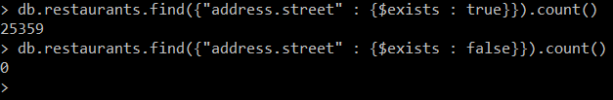
11. Before: 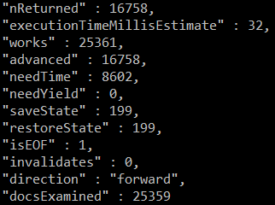

After: 